Monthly Staff Meeting of BAU Research System

Monthly staff meetings are an important function of any staff team. Staff meetings are regularly held in all workplaces in BAU Research System, Bangladesh Agricultural University, Mymensingh-2202. Professor Dr. M. A. M. Yahiha Khandoker, Director, BAURES is introduced staff meeting in every last Wednesday, of month from 10 .30am to 12.30pm. The second staff meeting was held on 06.12.2017 at BAURES’s meeting room from 10.30 am to 12.45pm all staff has participated. These meetings created an opportunity for the staff team, including all BAURES staff and management representatives to sit together and share information on all aspects of the BAU Research Management’s service and contribute to the success of the service and benefit all stakeholders.

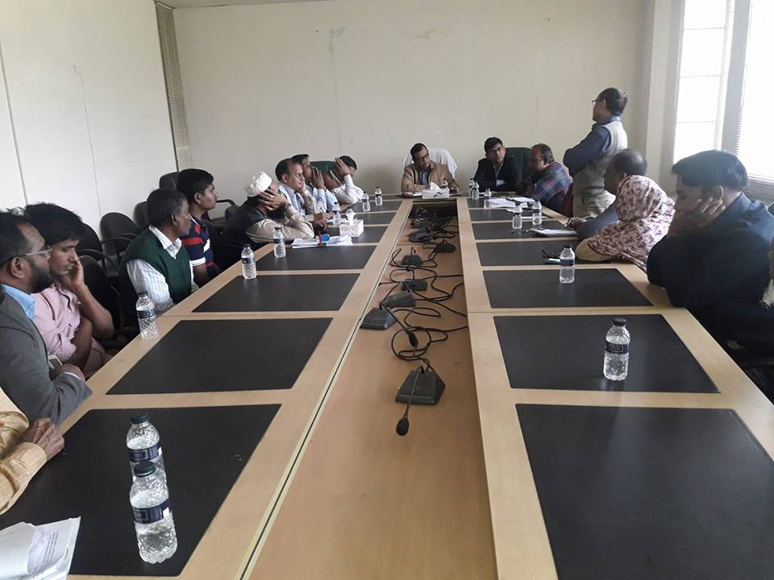

Figure: Monthly BAURES Staff Meeting on 06.12.2017

